



Debug Detective - Find, Fix & Optimize
LAB MANUAL

Disclaimer: The content is curated from online/offline resources and used for educational purpose only
Debug Detective – Find, Fix & Optimize
Objective
By the end of this lab, you will be able to:
- Identify common types of bugs in Python code (syntax, runtime, logical).
- Use GitHub Copilot to help explain, locate, and suggest fixes for errors.
- Apply debugging strategies: read error messages, use print statements, test small parts, ask Copilot targeted questions.
- Optimize simple code (make it faster, cleaner, or more efficient) with Copilot suggestions.
- Measure before-and-after improvements (e.g., fewer lines, faster run time for larger inputs).
- Build confidence in fixing code instead of rewriting it from scratch.
- Combine all previous Module 4 concepts (loops, functions, data structures) while debugging real-world-like buggy snippets.
Equipment Required
- Computer/Laptop with Windows, macOS, or Linux.
- Visual Studio Code (VS Code) installed and configured.
- Python 3.10 or higher installed and added to PATH.
- GitHub Copilot extension installed and activated in VS Code (signed in with GitHub account).
- Internet connection (required for Copilot suggestions and possible Copilot Chat).
Prerequisites
- Completed Module 3 and Labs 1–3 of Module 4 (loops, functions, lists/dictionaries, interactive programs).
- Comfortable running code, reading basic error messages (NameError, TypeError, IndexError, etc.), using input/print, loops, functions, and lists/dicts.
- Know how to accept Copilot suggestions (Tab), refine prompts, and use Copilot Chat if available (Ctrl+Shift+I or right-click → Ask Copilot).
- Able to create/run .py files in VS Code.
Procedure
Instructor will provide 4 buggy code snippets (either as separate .py files or one file with sections). Copy them into your workspace. Work systematically - don’t just accept every suggestion; understand why it fixes the issue.
- Preparation
  - Open VS Code.
  - Go to your Module 4 labs folder.
  - Create a new file: lab4_debug_detective.py
  - Save it and ensure Python interpreter is selected.
  - Add header:
# Lab 4: Debug Detective – Find, Fix & Optimize
# Objective: Use Copilot to debug and improve code
# Date: [Your Date]
- Part A: Buggy Snippet 1 – Infinite Loop & Logic Error
Instructor provides (or you paste):
count = 0
while count < 10
print(count)
count = count + 1
print("Done!")
  - Run it → observe error (SyntaxError: expected ':').
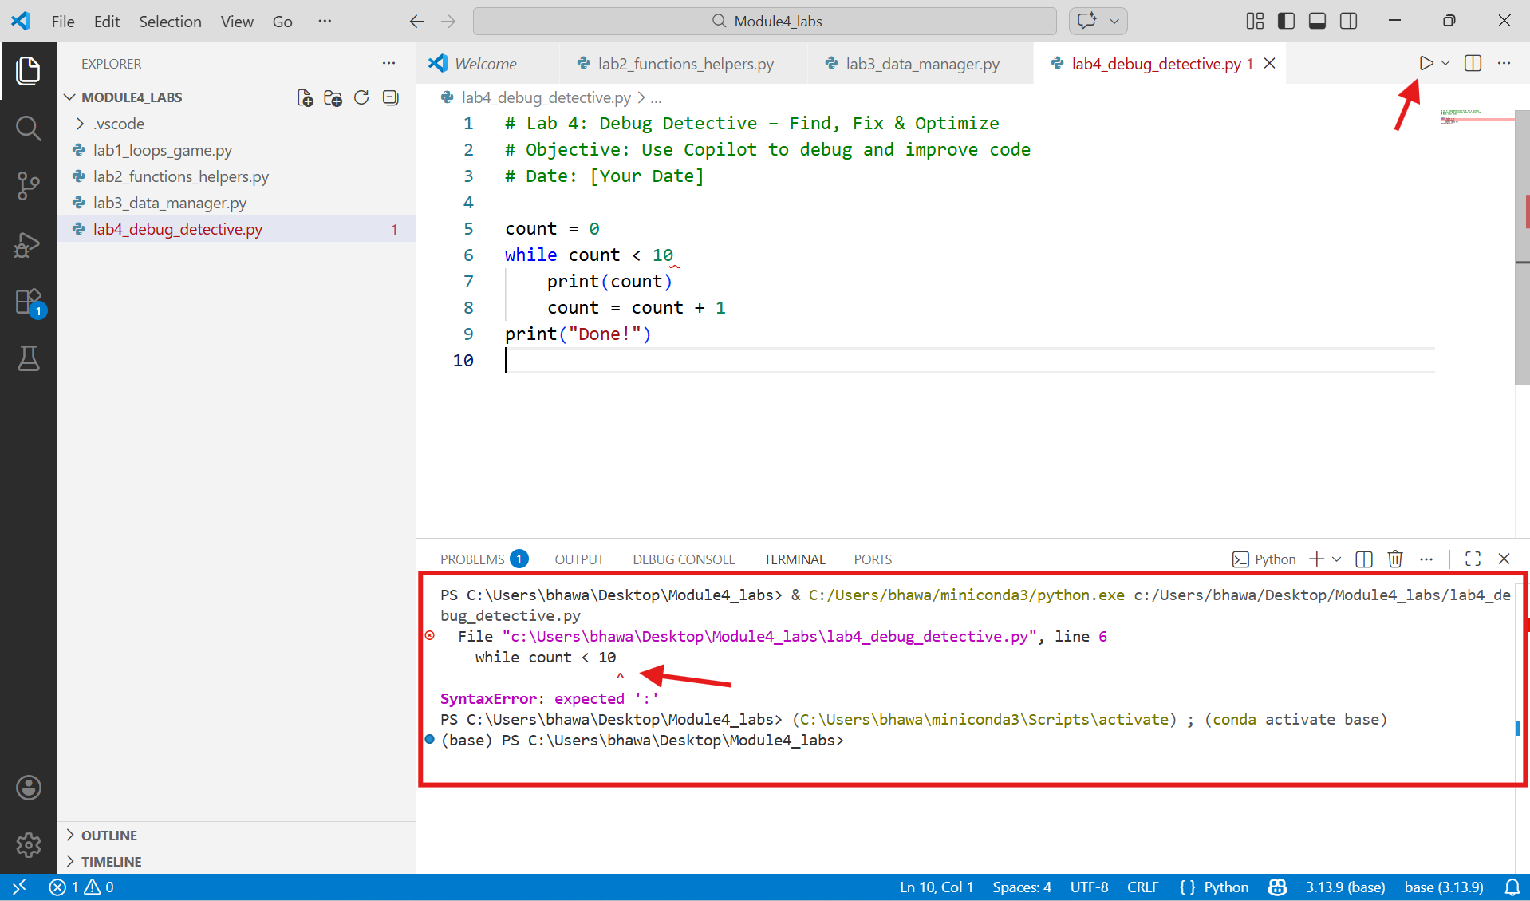
  - Highlight line → type comment above: # fix this syntax error → accept Copilot fix (add colon).
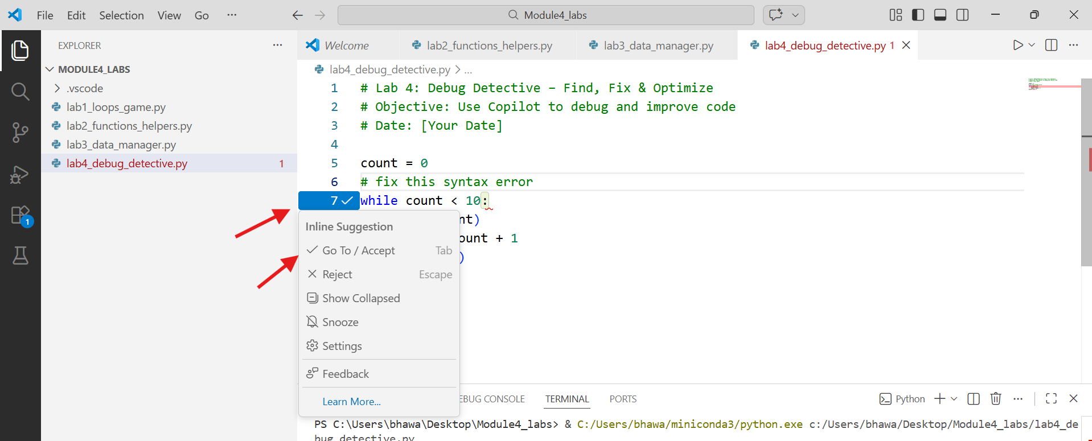
  - Run again → now infinite? No — wait, it runs but never stops? Wait, logic: count starts 0, <10, adds 1 → should stop at 10.
  - Actually it does stop. Change to: make it count from 1 to 10 (fix off-by-one). Prompt: # Change loop to print numbers 1 to 10 inclusive
  - Optimize: Use range(). Prompt: # Rewrite using for loop with range
  - Note time: Manual fix vs. Copilot time.
- Part B: Buggy Snippet 2 – List Index & Type Errors
Paste:
fruits = ["apple", "banana", "cherry", "date"]
for i in range(5):
print(fruits[i].upper())
  - Run → IndexError on i=4.
  - Ask Copilot: Highlight error line → # why this error? how to fix?
    - Common fix: use len(fruits) or range(len(fruits)).
  - Prompt: # Make it safe – loop over list without knowing length → accept for fruit in fruits:
  - Add bug: Change one fruit to number (e.g., fruits[2] = 100). Run → TypeError.
  - Fix with Copilot: # Handle if item is not string → add type check or convert.
- Part C: Buggy Snippet 3 – Function & Data Structure Issue
Paste (student marks manager with bugs):
def get_total_marks(student):
return student["marks"] + student["science"] + student["english"]

students = [
{"name": "Priya", "marks": 85, "science": 90, "english": 78},
{"name": "Rahul", "marks": {"math": 88, "science": 92}}
]

for s in students:
print(s["name"], "total:", get_total_marks(s))
  - Issues:
      - KeyError / TypeError in function (different structures).
      - Second student missing english.
      - Inconsistent dict keys.
  - Run → errors.
  - Prompt step-by-step: # Explain the error in get_total_marks# Fix function to handle marks as dict or int# Make all students have same structure
  - Final good version (Copilot helps): function sums dict values or handles single int.
  - Optimize: Add average calculation → prompt # Add function to get average marks.
- Part D: Mini-Optimization Challenge & Reflection
  - Take your Lab 3 shopping manager (or this file).
  - Make it slower on purpose: use many repeated print() instead of one loop.
  - Prompt: # Optimize this code to be more efficient and readable
  - Compare: before (slow/messy) vs. after (clean/faster).
  - Worksheet notes:
    - 3 types of bugs you fixed today.
    - Best Copilot debugging prompt.
    - One optimization you liked.
    - How confident do you feel debugging now (1–10)?
Conclusion
In this final lab of Module 4, you became a “Debug Detective” - using GitHub Copilot not just to write code, but to understand errors, explain them, suggest fixes, and improve existing programs. Debugging is one of the most important real-world programming skills, and Copilot acts like an expert partner that helps you learn faster instead of getting stuck.

